POWER BI ASSIGNMENT 1 :
DATA TRANSFORMATION & DATA MODELING
DATE OF SUBMISSION : 24/07/2026 – 08:00AM
PREVIEW SCREENSHOTS : QUESTIONS
- IMPORT DATA:
1.1) IMPORT “LIST OF ORDERS.CSV” INTO POWER BI
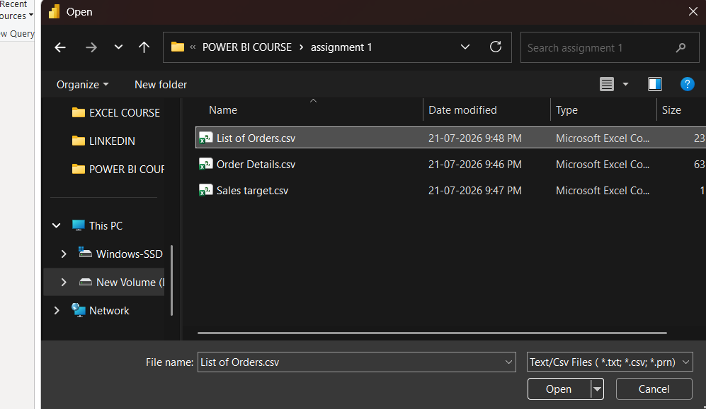
1.1.1) OPEN “LIST OF ORDERS” IN POWER QUERY EDITOR BY CLICKING ON
“TRANSFORM”.
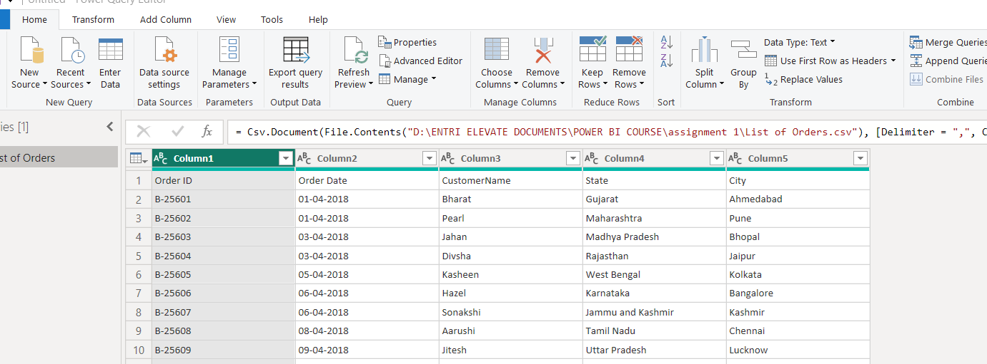
1.1.2) “USING FIRST ROW AS HEADER“ - IN “LIST OF ORDERS”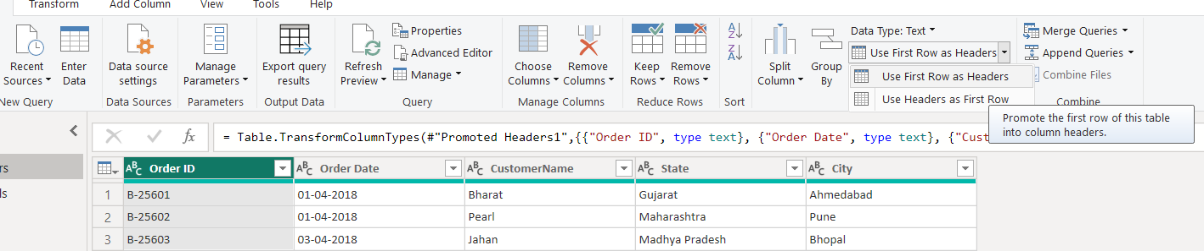

1.2) IMPORT “ORDER DETAILS.CSV” INTO POWER QUERY EDITOR.
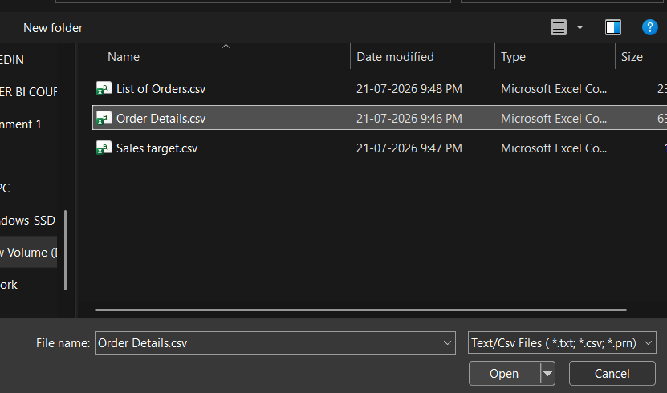
1.2.1) OPEN “ORDER DETAILS.CSV” IN POWER QUERY EDITOR BY CLICKING ON
‘TRANSFORM’.
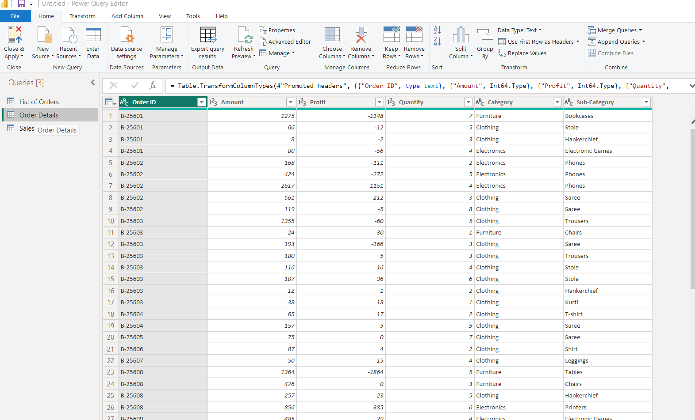

1.3) IMPORT “SALES TARGET.CSV” INTO POWER QUERY EDITOR.
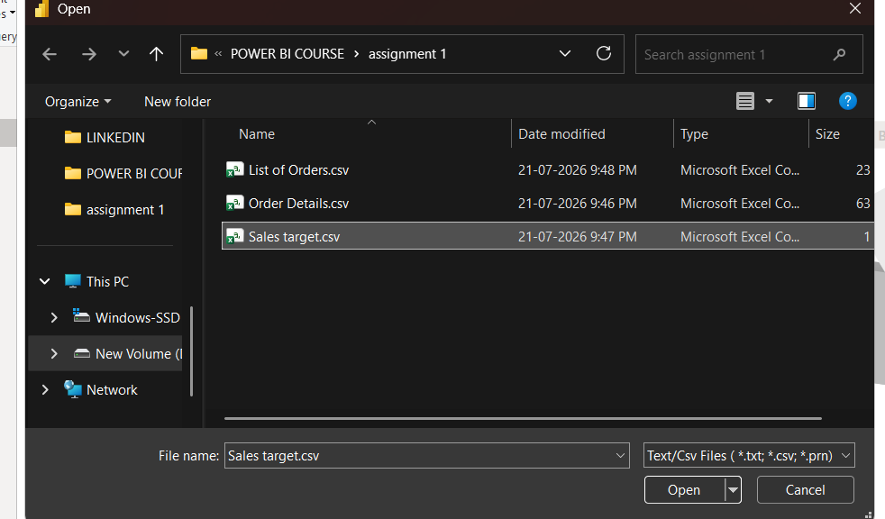
1.3.1) OPEN “SALES TARGET.CSV” IN POWER QUERY EDITOR BY CLICKING ON
‘TRANSFORM’.
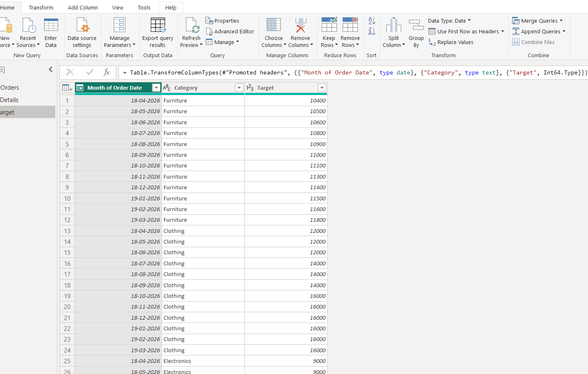

- DATA TRANSFORMATION:
2.1) DATA TRANSFORM IN “LIST OF ORDERS”.
2.1.1) "LIST OF ORDERS" TABLE TO ONLY THE FIRST 500 ROWS.

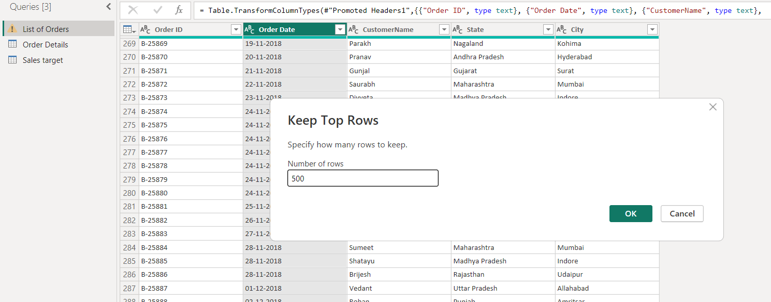
2.1.2) “ORDER DATE” COLUMN IN THE “LIST OF ORDERS” TABLE IS SET TO
DATA TYPE 'DATE'.
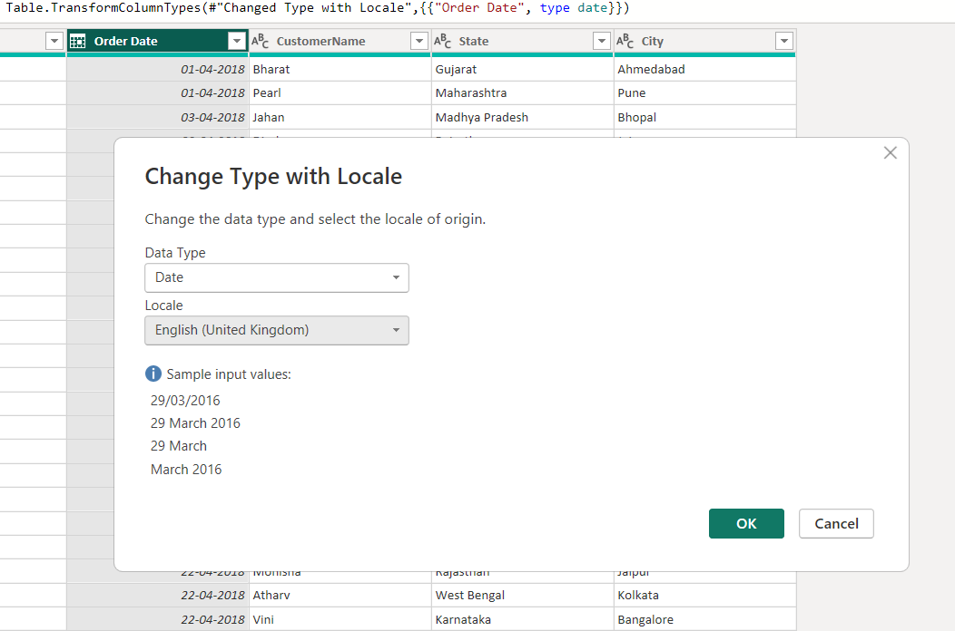
2.1.3) VIEW THE CHANGED “DATE” OF “ORDER DATE”
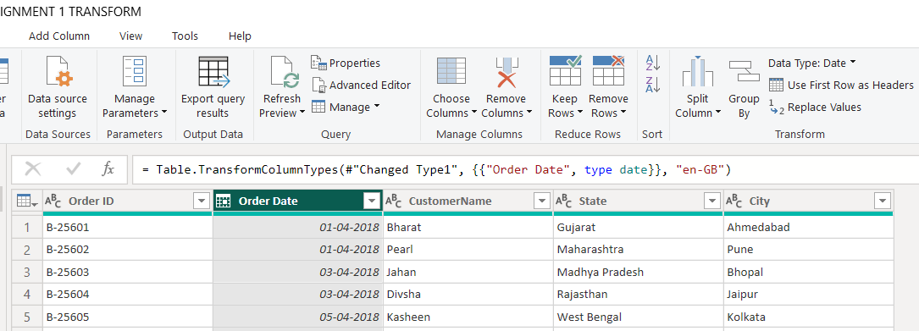

2.1.4) “AMOUNT” AND “TARGET” COLUMNS TO ‘FIXED DECIMAL NUMBER’.
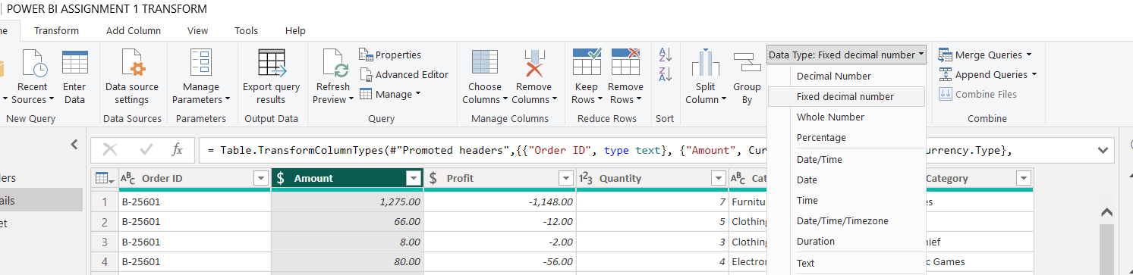
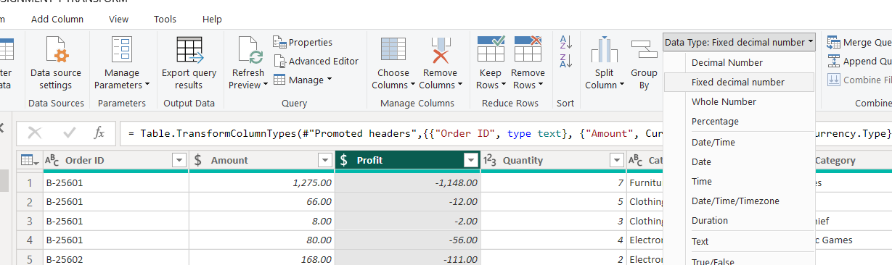
2.1.5) "CUSTOMERNAME" COLUMN INTO PROPER CASE, ENSURING CONSISTENT
“CAPITALIZATION FOR EACH WORD”.
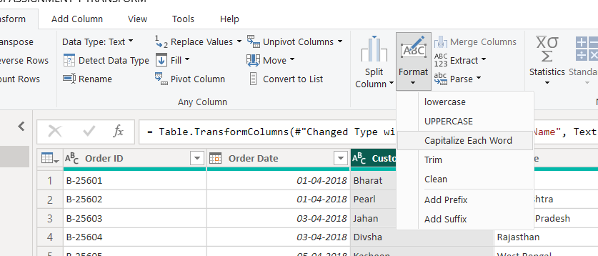
VIEW THE PROPER CASE OF “CUSTOMER NAME”
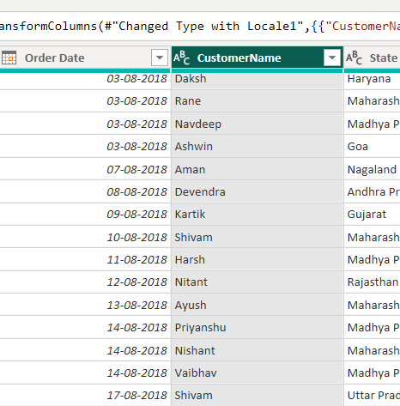
2.1.6) MERGE THE "STATE" AND "CITY" COLUMNS TO CREATE A NEW COLUMN
NAMED "LOCATION".
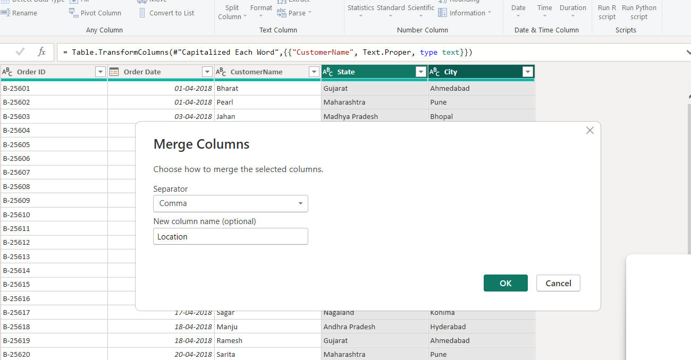
VIEW OF MERGE COLUME AS “LOCATION”.
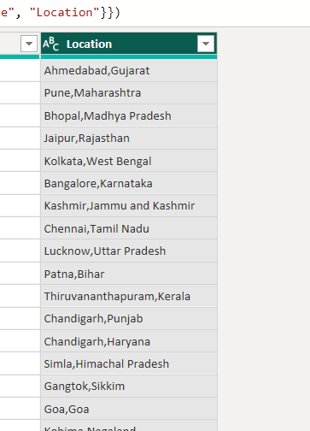

2.1.7) CREATE A NEW “CUSTOM COLUMN” NAMED "PROFIT MARGIN" AS THE
PERCENTAGE OF "PROFIT" DIVIDED BY "AMOUNT".
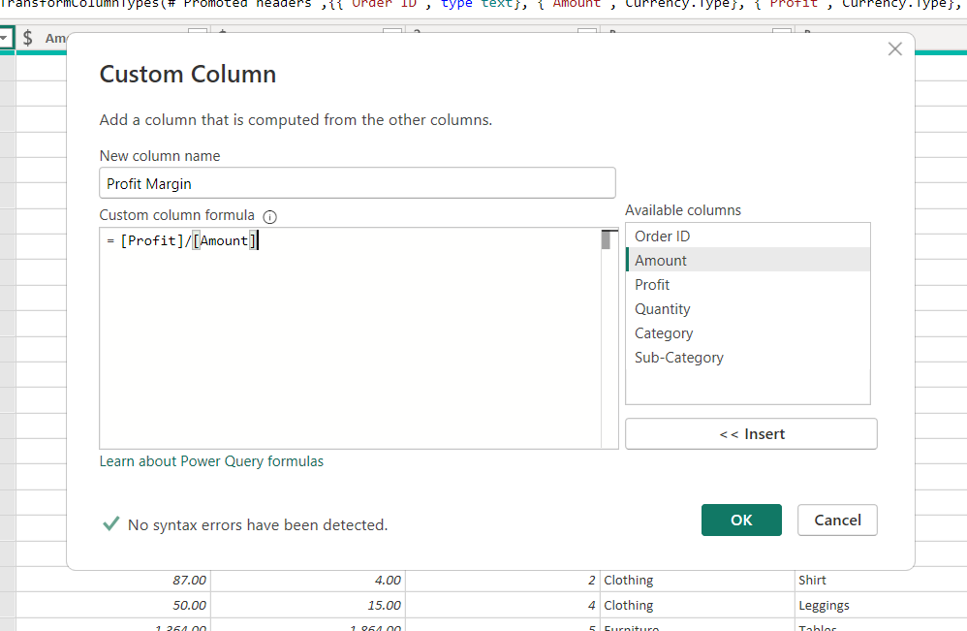

CHANGE TYPOS IN “PROFIT MARGIN” COLUMNS TO ‘FIXED DECIMAL NUMBER’.
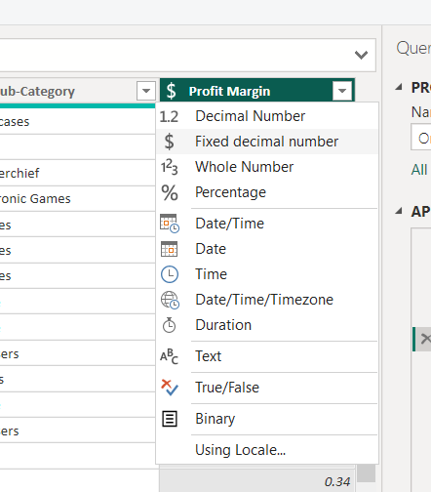-> 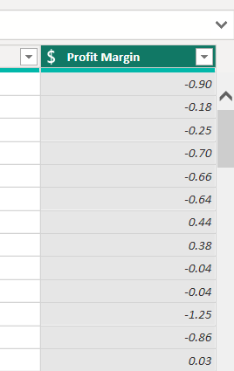
2.1.8) NEW CONDITIONAL COLUMN NAMED "PROFIT STATUS".
if [Profit] < 0 then "Loss"
else if [Profit] = 0 then "Break-Even"
else if [Profit] > 0 then “Profit”

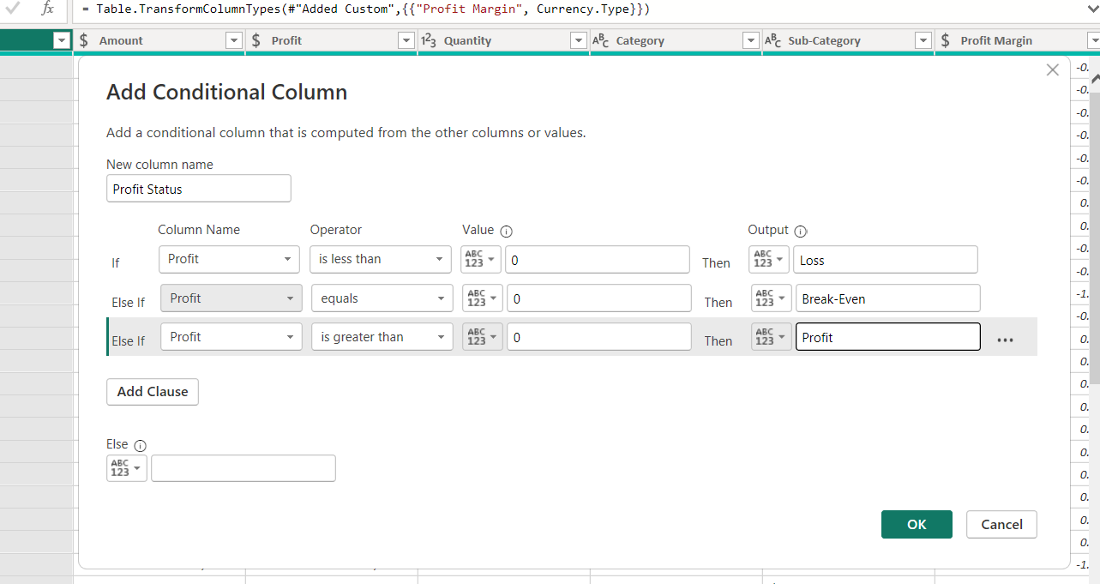
CHANGE TYPOS IN "PROFIT STATUS"COLUMNS TO ‘TEXT’.
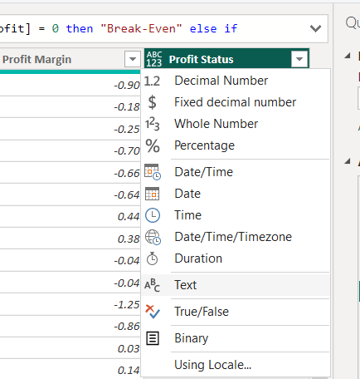->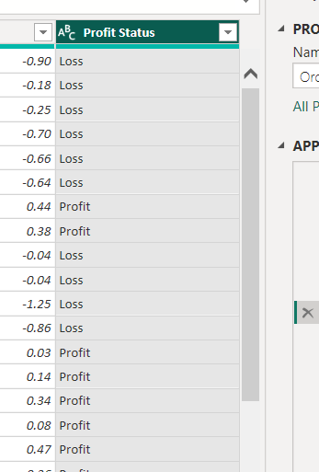

- MERGING DATA (JOINS):
3.1) MERGE THE "LIST OF ORDERS" AND "ORDER DETAILS" TABLES INTO A NEW SINGLE TABLE NAMED "ORDERS DATA" BASED ON THE "ORDER ID" RELATIONSHIP
“LEFT OUTER”.
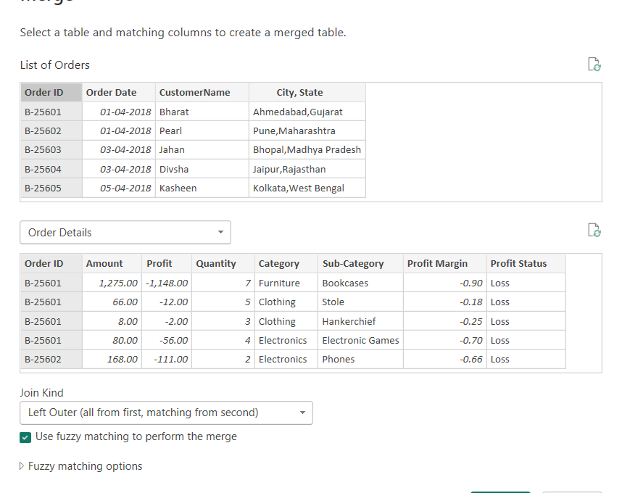
VIEW THE “ORDERS DATE”.
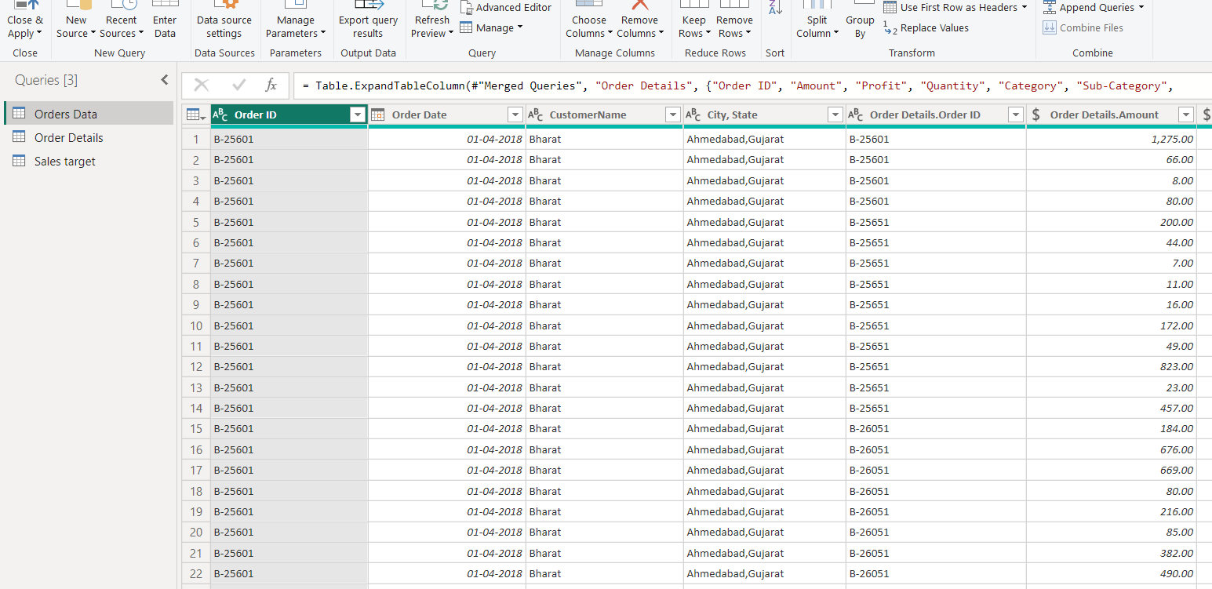

- HANDLING MISSING DATA & DUPLICATE DATA:
4.1) CHECK FOR “REMOVE DUPLICATE” IN EACH TABLES
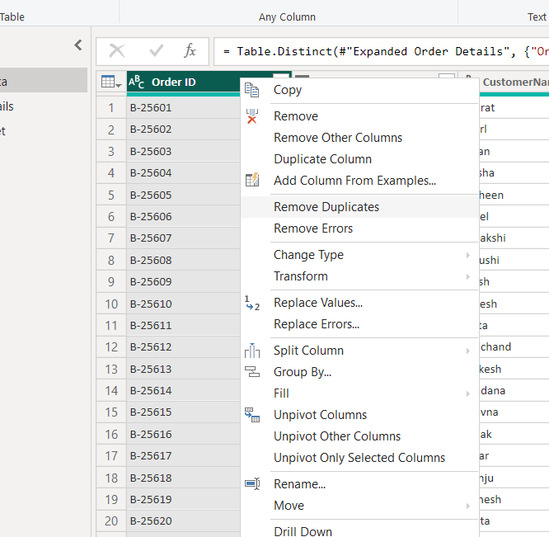
NO DUPLICATE VALUES
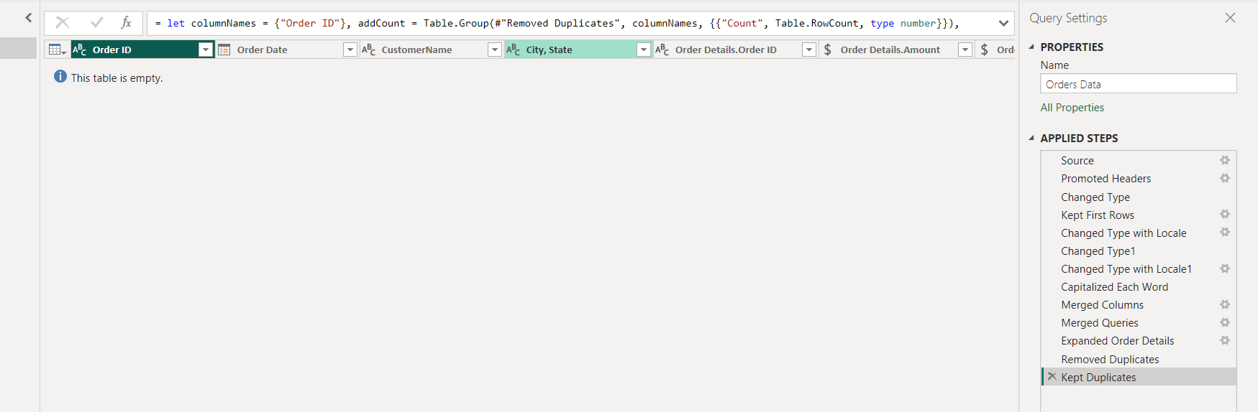

- SORTING AND FILTERING DATA:
5.1) ‘ORDERS DATA’ TABLE, SORTING AND FILTERING THE “ORDER DATE”, “STATE”
AND “CATEGORY”.
5.1.1) SORTING “ORDER DATE”.
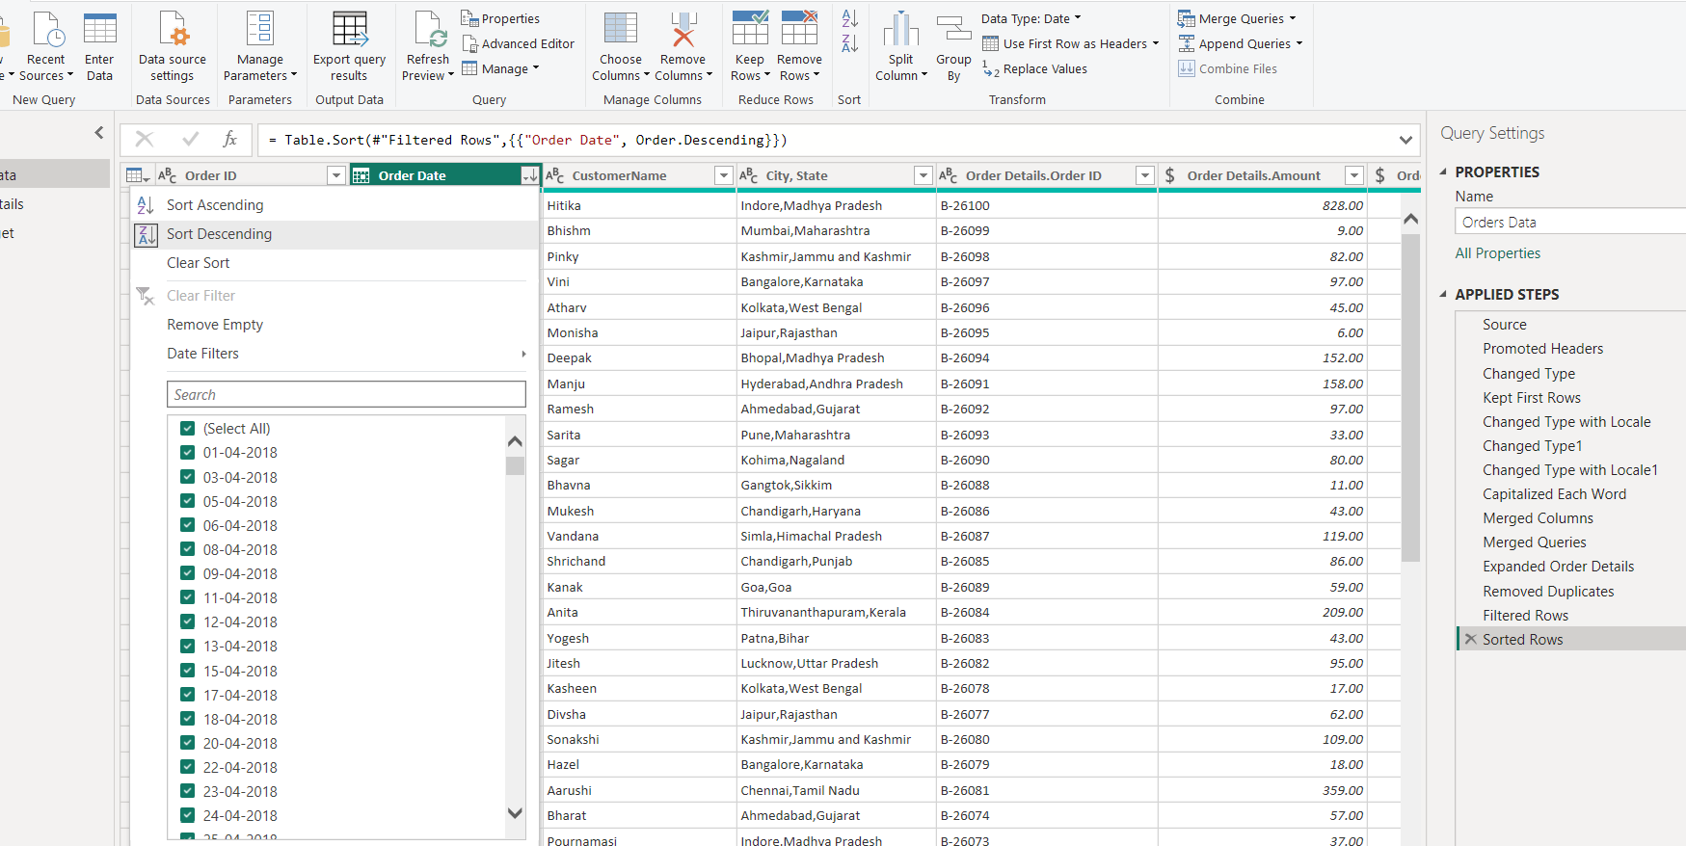

5.1.2) FILTERING “LOCATION” – “TAMIL NADU”.

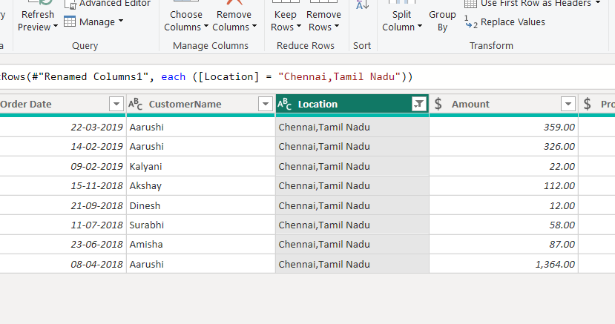

- GROUPING AND AGGREGATING DATA:
6.1) MAKE DUPLICATE OF “ORDER DETAILS”.
6.1.1) DUPLICATE OF “ORDER DETIALS(2)”.
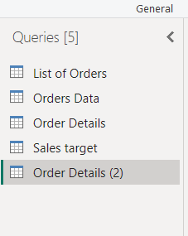
6.1.2) COUNT EACH “ORDER ID”. 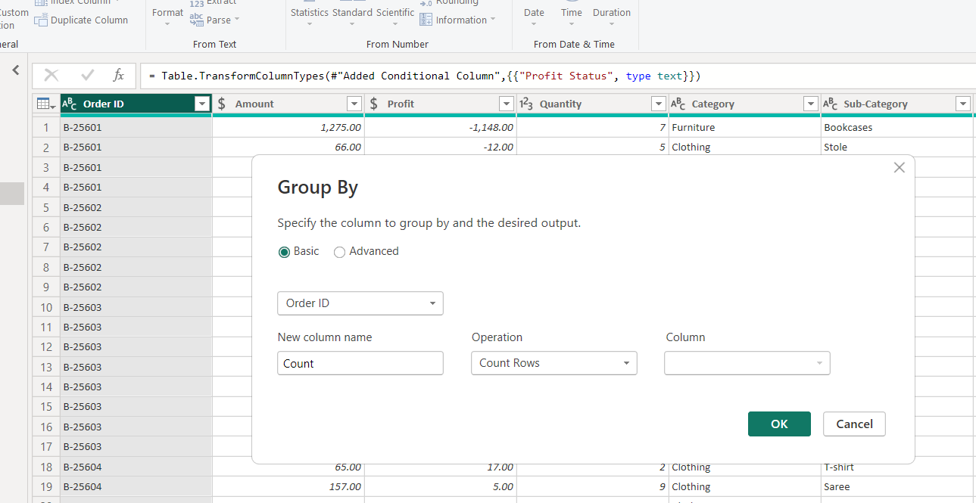
VIEW THE COUNT OF “ORDER ID” 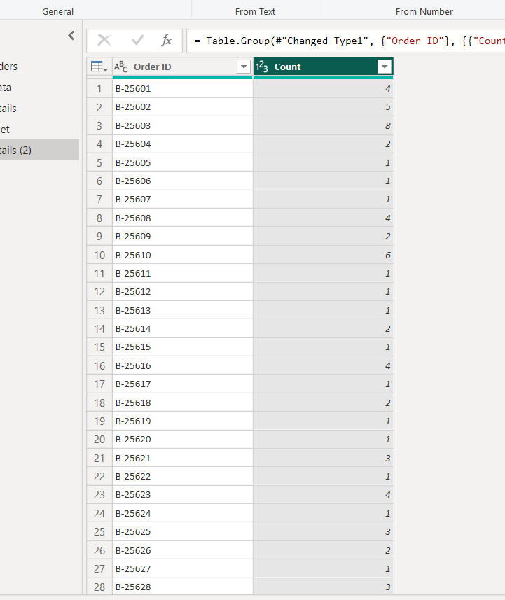

6.1.3) “AVERAGE PROFIT” BY CATEGORY.
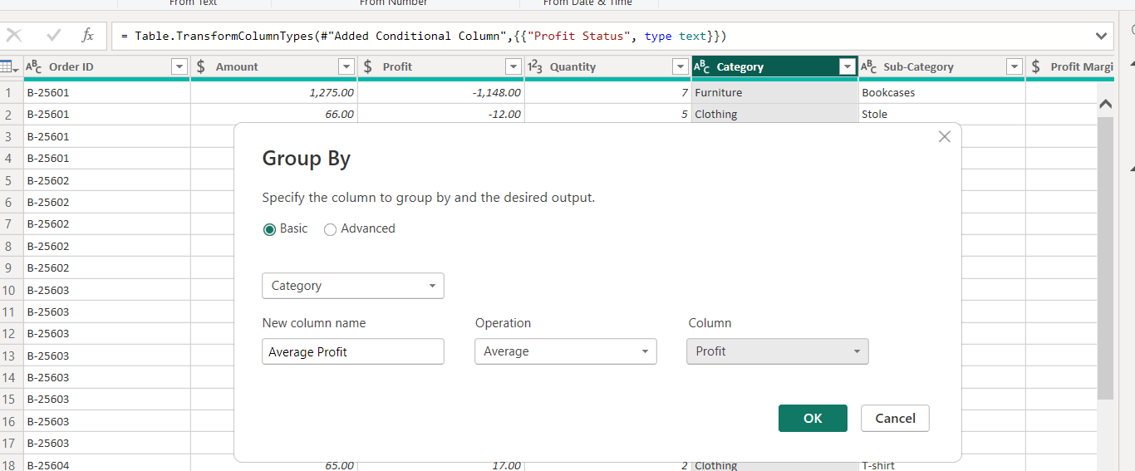
VIEW OF “AVERAGE PROFIT”.
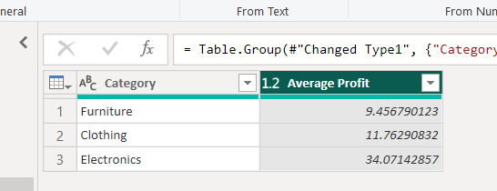

6.2) MAKE DUPLICATE OF “SALES TARGET”
6.2.1) DUPLICATE OF “SALES TARGET(2)”.
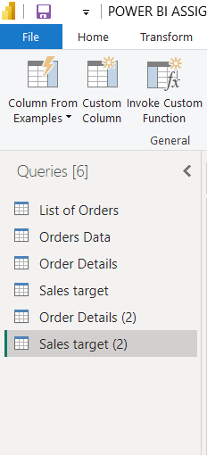
6.2.2) “TOTAL TARGET AMOUNT” BY MONTH OF ORDER DATE
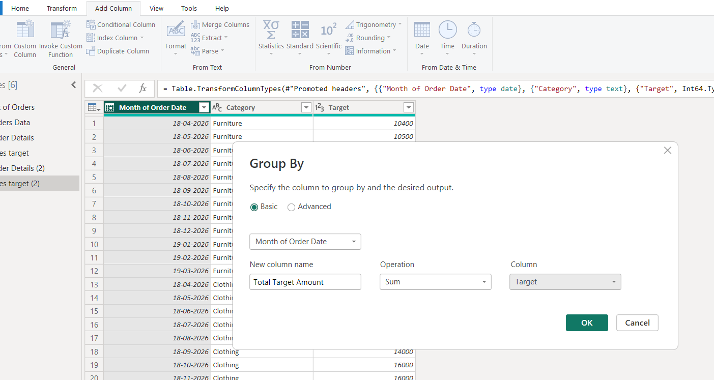
VIEW THE “TOTAL TARGET AMOUNT” 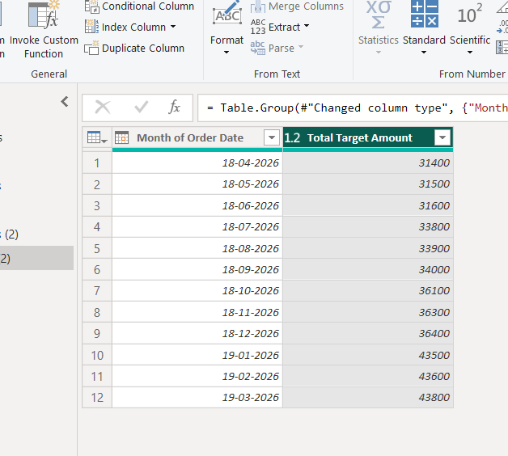
- DATA MODELING:
7.1) DATA MODELING “LIST OF ORDERS” AND “ORDER DETAILS” TABLES USING THE
‘ORDER ID’.
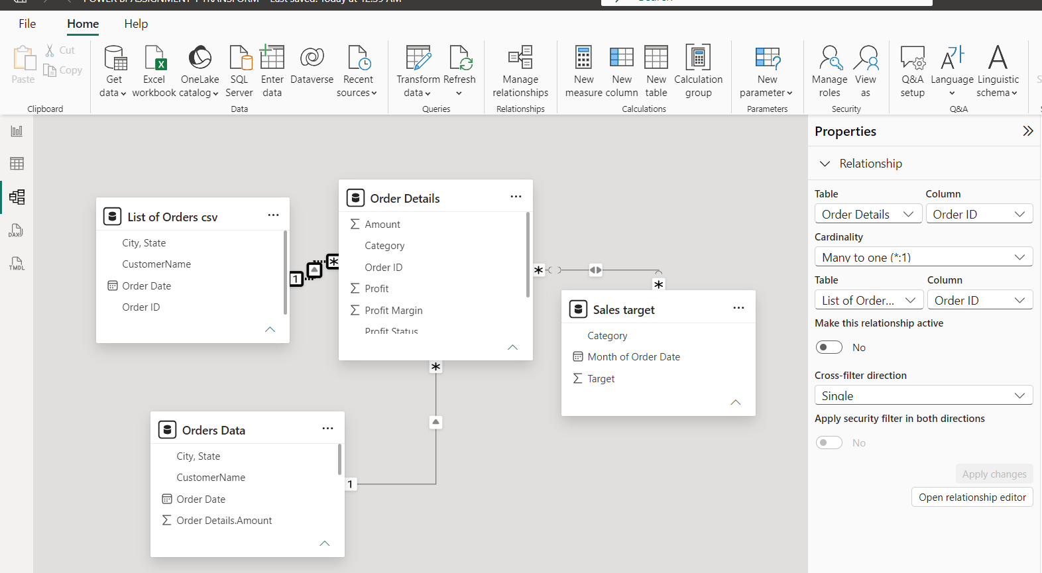
7.2) DATA MODELING “ORDER DETAILS” AND “ORDERS DATE” TABLES USING THE
‘ORDER ID’.
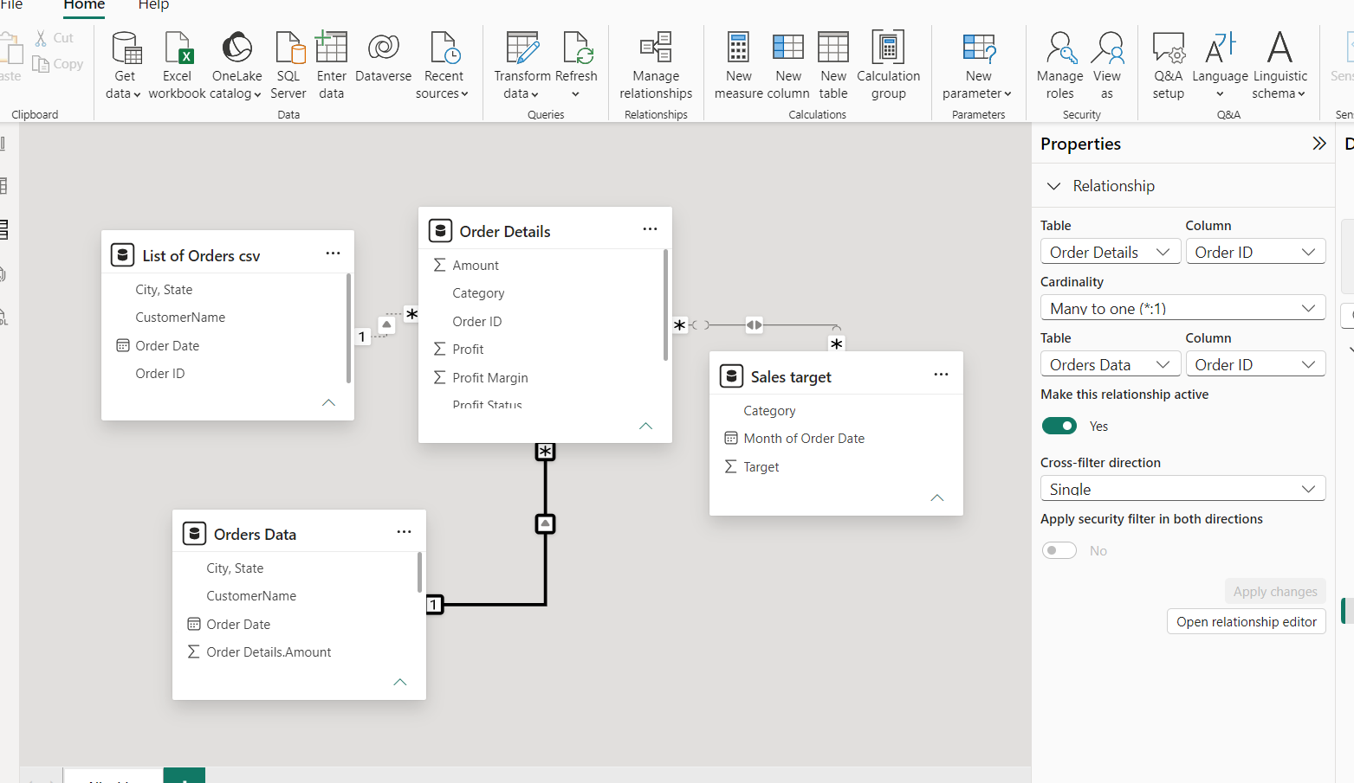

7.2.1) MANAGE RELATIONSHIPS TO “INACTIVE” TO “ACTIVE”.
STEP 1 - CLICK TO “MANAGE RELATIONSHIPS”
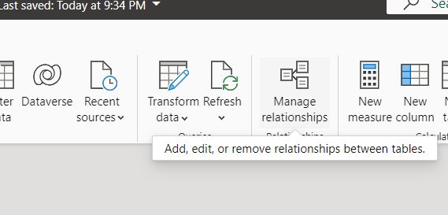
STEP 2 – CHECK ANY “INACTIVE” THAT MAKE TO “ACTIVE”
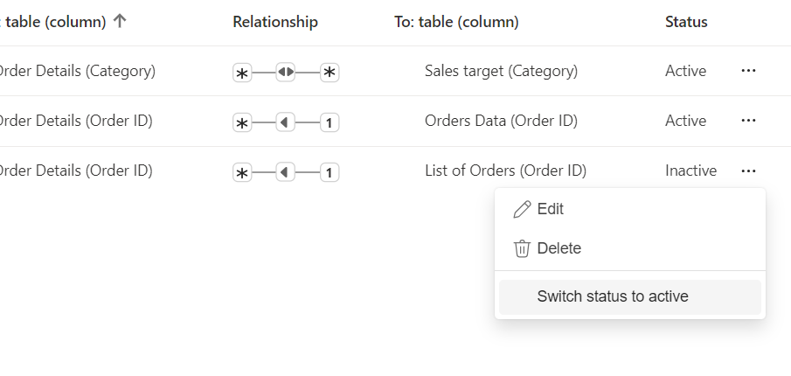
STEP 3 – WE CHANGE TO “ACTIVE”
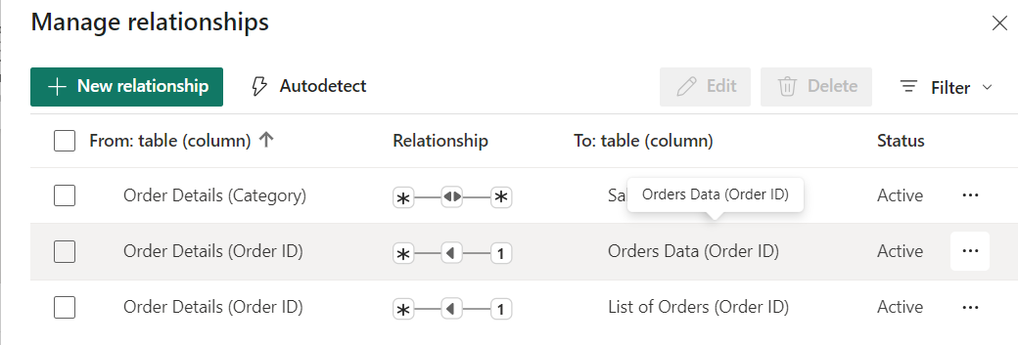

7.3) DATA MODELING “ORDER DETAILS” AND “SALES TARGET” TABLES USING THE
‘ORDER ID’.

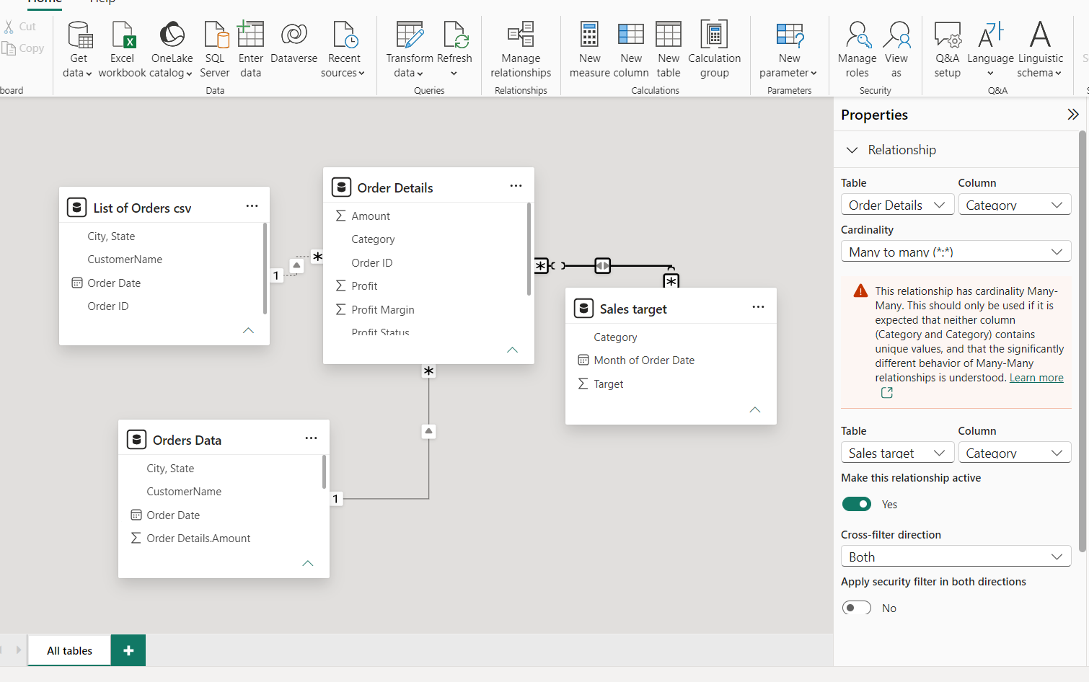

- VERIFICATION VIA CHARTS

